Flexbox Layout

Definition
# Source: AI Source: Provided by: [Data Path: Persons Table -> ID Column: 1, Name_En Column: Motasem Essam] -> From: [Chatgpt (GPT‑5 Mini)] on [2/12/2026]
Flexbox Layout is a web design technique in CSS that allows you to arrange, align, and distribute elements inside a container easily, even when their sizes are unknown or dynamic.

Simple Definition
# Source: AI Source: Provided by: [Data Path: Persons Table -> ID Column: 1, Name_En Column: Motasem Essam] -> From: [Chatgpt (GPT‑5 Mini)] on [2/12/2026]
Flexbox Layout = a flexible way to arrange elements in a row or column.

How Flexbox Layout Works
# Source: AI Source: Provided by: [Data Path: Persons Table -> ID Column: 1, Name_En Column: Motasem Essam] -> From: [Chatgpt (GPT‑5 Mini)] on [2/12/2026]
• A container is set to display: flex
• Inside it, elements (items) are automatically arranged
• You can control direction (row or column)
• You can align items horizontally and vertically
• Items can grow, shrink, or wrap depending on space

Purpose of Flexbox Layout
# Source: AI Source: Provided by: [Data Path: Persons Table -> ID Column: 1, Name_En Column: Motasem Essam] -> From: [Chatgpt (GPT‑5 Mini)] on [2/12/2026]
• Make layout design easier and more flexible
• Align items perfectly (center, left, right, space-between, etc.)
• Adapt layouts to different screen sizes
• Reduce complex CSS positioning
• Improve responsiveness

Advantages
# Source: AI Source: Provided by: [Data Path: Persons Table -> ID Column: 1, Name_En Column: Motasem Essam] -> From: [Chatgpt (GPT‑5 Mini)] on [2/12/2026]
• Easy to use for alignment
• Works well for responsive design
• Reduces need for float or positioning hacks
• Flexible and dynamic layout control
• Good for navigation bars, buttons, and sections

Disadvantages
# Source: AI Source: Provided by: [Data Path: Persons Table -> ID Column: 1, Name_En Column: Motasem Essam] -> From: [Chatgpt (GPT‑5 Mini)] on [2/12/2026]
• Not ideal for complex two-dimensional layouts (rows and columns together)
• Can become confusing when used for large and complex page structures
• Limited control compared to Grid for overall page layout
• Requires understanding of Flexbox properties to use effectively
• Can be difficult to debug when layouts don’t behave as expected
• Overuse can lead to messy or hard-to-maintain code
• Not always the best choice for full webpage structure (better for components)

Examples
# Source: AI Source: Provided by: [Data Path: Persons Table -> ID Column: 1, Name_En Column: Motasem Essam] -> From: [Chatgpt (GPT‑5 Mini)] on [2/12/2026]
• Centering a box both vertically and horizontally
• Creating a horizontal navigation menu
• Aligning buttons evenly in a row
• Building responsive card layouts

Difference Between Flexbox Layout and Grid Layout
# Source: AI Source: Provided by: [Data Path: Persons Table -> ID Column: 1, Name_En Column: Motasem Essam] -> From: [Chatgpt (GPT‑5 Mini)] on [2/12/2026]
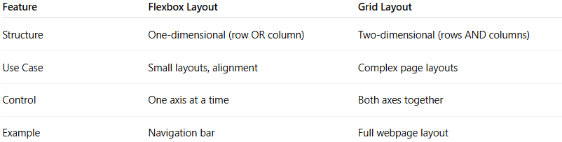
Feature | Flexbox Layout | Grid Layout
Structure | One-dimensional (row OR column) | Two-dimensional (rows AND columns)
Use Case | Small layouts, alignment | Complex page layouts
Control | One axis at a time | Both axes together
Example | Navigation bar | Full webpage layout

